Objective:
This project aims to demonstrate wireless transmission of electrical energy without any physical connection between wires. Using magnetic inductive coupling, a transmitter coil energized by a transistor based oscillator circuit induces a voltage in a nearby receiver coil to power an LED.

Working Principle:
The system utilizes magnetic coupling between two coils placed a few centimeters apart. An oscillating current generated by a 2N2222A transistor oscillator circuit flows through the transmitter coil, creating a time varying magnetic field. This magnetic field induces a current in the receiver coil via mutual inductance, which lights up an LED. No wired connection exists between the power source and the LED.

System Description and Diagram:

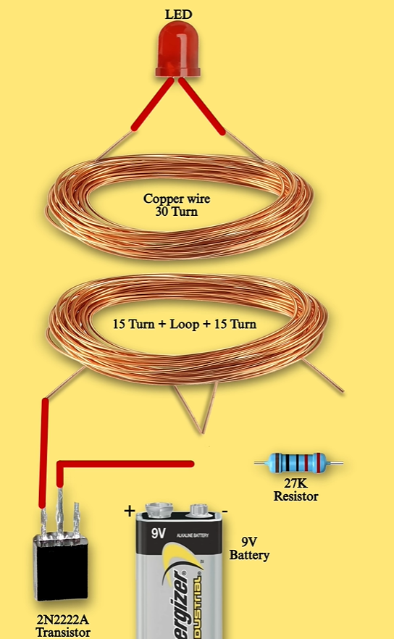

Transmitter Side:
The power source is a 9V battery, which supplies energy to the circuit. A 2N2222A NPN transistor is used as a fast switching device to create oscillations in the circuit. The transmitter coil has a total of 30 turns, divided as 15 turns on each side of a center tap. A 27KΩ resistor is placed between the battery’s positive terminal and the base of the transistor to provide proper biasing, ensuring the transistor turns on and off repeatedly. The coil and transistor form a feedback loop, generating an alternating magnetic field.
Receiver Side:
The receiver coil is made of 30 turns of copper wire and is positioned above the transmitter coil. An LED is connected directly across the receiver coil. As the oscillating magnetic field passes through the RX coil, it induces an alternating voltage. When this induced voltage is sufficient to forward-bias the LED, it lights up wirelessly.

Why These Components Are Used?
- Copper Wire: Enamel coated wire is used because it allows tight winding of coils while avoiding short circuits. More turns mean stronger magnetic fields and better inductive coupling.
- 2N2222A Transistor: This general purpose NPN transistor is chosen for its fast switching speed and ability to handle moderate currents, making it suitable for creating oscillations.
- 27KΩ Resistor: This resistor sets the base current of the transistor, ensuring proper oscillation without damaging the transistor or battery.
- 9V Battery: A simple and portable DC power source that supplies enough voltage to drive the transistor and generate a strong magnetic field.
- LED: The LED visually confirms the successful transfer of power. A red LED is ideal due to their low forward voltage requirements.

Construction Steps:
- Wind the transmitter coil with 15 turns, leave a loop, and then wind another 15 turns to create a center tapped coil.
- Wind the receiver coil with 30 turns of the same copper wire.
- Connect the center tap of the TX coil to the positive terminal of the 9V battery through a 27K resistor.
- Connect one end of the TX coil to the collector of the 2N2222A transistor, and connect the emitter of the transistor to the battery’s negative terminal.
- Connect the base of the transistor to the junction point of the resistor and center tap to form the feedback loop.
- Place the RX coil directly above the TX coil with a small air gap (2 – 4 cm).
- Power the circuit using the 9V battery and observe the LED lighting up if coupling is successful.

Results:
The LED on the receiver side lit up when the RX coil was positioned above the TX coil and the circuit was powered. Energy was transferred without physical contact, demonstrating wireless power transfer. The LED was brightest when the coils were closely aligned and at a distance of around 2–3 cm.

Conclusion:
This project successfully demonstrates the concept of wireless power transfer using magnetic coupling. By employing a simple self-oscillating circuit with a transistor and properly wound coils, electrical energy can be transmitted without direct contact. The 2N2222A transistor acts as a switch to create high-frequency oscillations, and the coils serve as the medium for magnetic energy transfer. This experiment illustrates the basic working principle behind many modern wireless power systems, including wireless phone charging and RFID technologies.
Group Members:-
Syed Muhammad Haider Zaidi (mz10270)
Syed Sualeh Abbas Rizvi (sa10303)
Syed Muhammad Ali Hussain Zaidi (sz10384)

